# Get friend info

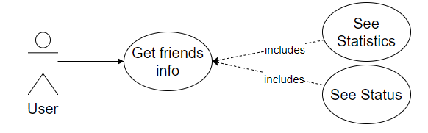

## Characteristic Information

|  |  |
| --- | --- |
| Superior business process: | Process-ID: refers to section 2.5.1 (business processes)> |
| Goal: | Get more info about the chosen friend |
| Precondition: | The user needs to have a friend in his friend list |
| Postcondition: | The user saw interesting info |
| Involved User: | The User choses the option and got the info |
| Triggering Event: | The User choses the option from a friend |

## GUI to call the use case

| Input field | Valid inputs |
| --- | --- |
| MessageTextBox | As in communicate with friends |

## GUIs for the standard use

| Step | User | Activity |
| --- | --- | --- |
| 1 | User | Start program |
| 2 | User | Select a friend |
| 3 | User | Click the stat option/look at the stats |

## Scenarios for non-standard uses (bad cases or work around cases)

## GUIs for the non-standard uses

## Workflow

## Open Points